Time-varying heart disease and risk of Cognitive Decline among older adults: A survival Analysis Using NHATS Data
Abstract
Introduction
Cognitive decline is a growing public health issue among older adults. Heart diseases are known as a risk factor for cognitive impairment. However, most studies relied on baseline measures and ignore changes in heart disease status over time. This study assessed association between time-varying heart disease and cognitive decline risk using National Health and Aging Trends Study (NHATS) data.
Methods
We analyzed data of 6058 participants aged ≥65 years enrolled in 2011 without cognitive impairment and followed through 2024. Exposure was defined as time-varying heart disease status and heart attack, updated at each wave through self-reported physician diagnosis. The outcome was incident cognitive decline. Time-to-event was measured from baseline to onset of event or censoring. Cox proportional hazards models with time-varying covariates estimated hazard ratios (HRs) and 95% confidence intervals (CIs) adjusting for demographics, education, body mass index, physical activity, and sleep difficulties. Proportional hazard assumptions and model discrimination C-index) were evaluated.
Results
At baseline,57% were females, 83% were white non-Hispanics. During follow-up, 1913 participants (32%) developed cognitive decline. Heart disease was associated with higher risk of cognitive decline in unadjusted model (HR= 1.30, 95%CI: 1.10 to1.53). and in fully adjusted model (HR= 1.34, 95%CI: 1.13 to 1.60, C-index =0.64). Heart attack showed a stronger association with risk of cognitive decline (HR= 2.75, 95%CI: 2.08 to 3.64, C-index= 0.64).
Conclusion
Heart disease and heart attack are independently associated with a higher risk of cognitive decline. These findings suggested the importance of cardiovascular management to reduce or delay cognitive decline in aging populations.
Keywords: Cognitive decline; heart disease; Heart attack; NHATS

Introduction
Cognition is the mental process of acquiring knowledge and understanding through thought, experience, and senses. It encompasses various aspects of high-level brain functions and processes such as attention, memory, knowledge, decision-making, planning, reasoning, judgment, perception comprehension, language, and visuospatial function [1]. Cognitive impairment presents as dysfunction in one or more of these cognitive domains and can range from mild cognitive impairment (MCI) to probable dementia to dementia. Cognitive impairment represents an escalating fiscal, societal, and public health crisis as the global population continues to age[2].
According to the World Health Organization (WHO), more than 55 million people globally suffer from dementia, and over 60% of these individuals reside in low- and middle-income countries[3]. The global prevalence of mild cognitive impairment is 15.6% (95%CI: 13.2 to 18.0) [4]. The incidence of MCI has been estimated at 41.0 per 1,000 person-years, and participants converted to probable dementia at a high rate of 241.3 per 1,000 person-years, though a small proportion reverted from MCI to cognitively normal status[5].
Cardiovascular diseases (CVDs) are a group of heart disorders and blood vessels diseases and are the leading cause of death globally. CVDs include coronary heart disease, cerebrovascular disease, peripheral arterial disease, rheumatic heart disease, congenital heart disease, deep vein thrombosis and pulmonary embolism. Heart attacks and strokes are usually acute events and are mainly caused by blockage that prevents blood from flowing to the heart or brain. As of 2023, there were 437 million CVD disability-adjusted life years (DALYs) globally, representing a 1.4-fold increase from 320 million in 1990 [6]. In the United States, CVDs including coronary heart disease, heart failure, atrial fibrillation and stroke affected approximately 28.6 million total adults aged >20 years, representing 9.9% of this population [7].
The co-occurrence of heart disease and cognitive impairment is well recognized. One in three patients presenting at cardiology clinics have some degree of cognitive impairment, depending on the cardiac condition, comorbidities, and age [8]. Every year, approximately half a million persons are diagnosed with myocardial infarction (MI) in the United States, with adults aged 65 to 75 years having around a tenfold greater incidence rate compared to younger adults [9].
Heart disease can lead to cerebral damage and impaired cognition through mechanisms such as cerebral hypoperfusion, thromboembolism, and systemic inflammation [10, 11]. At the same time, treatment of heart disease may also benefit cognition, and early recognition of cognitive impairment in cardiac patients may support timely risk factor management and prevent further cognitive decline [12].
Despite this established link, important gaps remain in literature. Prior studies have established associations between heart disease and cognitive impairment or dementia, but many analyses rely on baseline cardiovascular status and do not account for changes in heart disease or heart attack status over time. This results in immortal time bias, misclassifying before exposure occurred. There is limited understanding of dynamic risk over time. The biological pathway through which each cardiac condition affects cognition remained poorly characterized in longitudinal population data and there is limited evidence in disparities in heart disease or heart attack to risk cognitive impairment pathway by sex and income. Time-varying exposure modeling can help to determine whether updating cardiovascular status at each follow-up wave alters risk of cognitive decline. NHATS’s longitudinal design and rich data make it possible to investigate the research question.
Therefore, this study aimed to determine the association of time-varying effects of heart disease and heart attack with cognitive decline among older adults using NHATS data.

Methods
Data source: We analyzed longitudinal data from round 1 to 14 of participants from the National Health and Aging Trend Study (NHATS) enrolled in the year 2011 [13]. NHATS collect data from nationally representative samples of Medicare beneficiaries aged 65 and above. NHATS is being led by the Johns Hopkins University Bloomberg School of Public Health and the University of Michigan’s Institute for Social Research, with data collection by Westat and support by the National Institute on Aging [14].

Study Population
In first cohort of NHATs enrolled in the year 2011, there were 8245 participants aged 65 years and above. Of which, we will exclude participants those with cognitive impairment (n= 1550) at baseline and those with missing information about cognitive impairment at baseline (n=637). We will analyze the data of 6058 participants from NHATs.
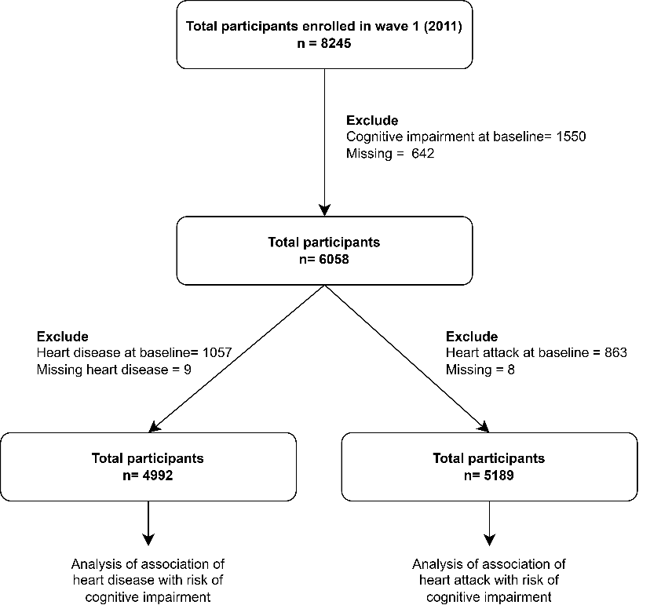
Figure 1 Study population

Variables
Outcome variable
Cognitive impairment: The primary outcome incident cognitive impairment, defined as the first occurrence of cognitive impairment during follow-up. First, cognitive impairment was classified into 3 groups: probable dementia, mild cognitive, and cognitively normal based on a protocol developed by NHATS investigators with reasonably good sensitivity and specificity. Probable dementia will be determined by 1) a self-report or proxy-report of Alzheimer’s disease or dementia diagnosis; or 2) AD8 scores ≥2, or 3) a score of ≤1.5 standard deviations below the mean in at least two to three (orientation, memory, and executive functioning) cognitive functioning domains. Mild cognitive impairment (MCI) will be defined by a score of ≤1.5 standard deviations below the mean in at least one of the three cognitive tests. Respondents who meet neither the standard for dementia nor the standard for MCI was classified as cognitively normal [5, 15].
For the primary analysis, a binary outcome was created in which individuals classified as either MCI or probable dementia were considered to have incident cognitive impairment, while those who meet neither criterion were classified as cognitively normal [5, 15].

Time to event: It was defined using age as underlying time scale. Participants entered the risk set at their age at baseline interview (2011) and were followed until the age at which the participant developed cognitive impairment, were censored, or died whichever occurred first. To account time-varying exposure, the data was structured in a counting process (start-stop) format, where each participant contributed multiple observation interval across survey waves. For each interval, the start and stop age corresponded to the participant’s age at the beginning and end of the interval, respectively. The event indicator was coded as 1 if incident cognitive impairment occurred during the interval and 0 otherwise. Participants free of cognitive impairment were censored at their age at last follow-up or death. Individuals with cognitive impairment at baseline were excluded from the analysis.

Exposure variable
The time varying exposures for this study were (1) heart disease, capturing chronic cardiac conditions including angina and congestive heart failure and (2) myocardial infarction (MI/heart attack. These cardiac exposure variables were constructed using self or proxy reported physician diagnosis data collected at each NHATS wave. Respondents (or their proxies) were asked whether a doctor had ever told them they had heart disease including angina or congestive heart failure, and b) a heart attack or myocardial infarction. These items were ascertained separately at each wave, consistent with the NHATS chronic condition module design. Individuals with heart disease or heart attack at baseline were excluded from the analysis.

Covariate: This study included covariates such as age (65-70 years, 70-75years, 75-80years, 80-85 years, 85+ years), gender (male/female), Race (White/Black/Asian), income level (low/moderate/high), BMI (kg/m²), physical activity (active/inactive), sleep difficulties (present/absent). Income level was defined using the federal poverty level (FPL) and classified into three categories: low income (FPL < 138%), moderate income (FPL 138% to < 400%), and high income (FPL ≥ 400%)[16].

Statistical analysis
We assessed baseline characteristics of study participants using frequency and percentage for categorical and mean and standard deviation (or median and interquartile range) for numerical variables.
We applied time-varying cox regression models to estimate hazard ratios (HRs) and 95% confidence intervals (CI) for the association between heart disease and incident cognitive impairment. HR > 1 was indicated as increased risk of cognitive impairment associated with heart disease. We generated multiple models, unadjusted model (model 1), partially adjusted for age, sex and race (model 2), and partially adjusted for age, gender, race, education (model 3), and fully adjusted model for age, gender, race, level, education, BMI, and physical activity and sleep difficulties (model 4). We also carried out sub-group analysis based on sex and age to evaluate association of heart disease and heart attack with the incident cognitive impairment. The theoretical are presented in table 1.
We plotted predicted cognitive impairment-free survival curves from the Cox model using fixed reference groups (heart attack vs. no heart attack or heart disease vs no heart disease) for illustrative purposes. These curves represent model-predicted survival conditional on cognitive impairment-free status at study entry and should be interpreted as group-level predictions rather than individual-level trajectories.

Table 1 Theoretical models
Model 1 | $$h_{i}\left(t|{Heartdisease}_{i}(t\right))=h_{0}\left(t\right) exp⁡(β1*{Heardisease}_{i}\left(t\right))$$  Where, h_{i}(t| Heartdisease_{i} (t), X): hazard of cognitive impairment at time t and X covariates  h₀(t): baseline hazard function  Heartdisease_{i}(t): time varying exposure
Model 2 | $$h_{i}\left(t|{Heartdisease}_{i}(t\right), Sex, Age, Race )=h_{0}\left(t\right) exp⁡(β1*{Heardisease}_{i}\left(t\right)+ β2*{{Sex}_{i}}_{Mvs F}+ β3*{{Race}_{i}}_{1Vs2}+β4β4*{{Race}_{i}}_{1Vs3}+β5*{{Race}_{i}}_{1Vs3}+β5*{{Race}_{i}}_{1Vs4}+ β6*{{Race}_{i}}_{1Vs5} )$$  Where, h_{i}(t| Heartdisease_{i} (t), X): hazard of cognitive impairment at time t and X covariates  h₀(t): baseline hazard function  Heartdisease_{i}(t): time varying exposure
Model 3 | $$h_{i}\left(t|{Heartdisease}_{i}(t\right), Sex, Age, Race, Income, Education )=h_{0}\left(t\right) exp⁡(β1*{Heardisease}_{i}\left(t\right)+ β2*{{Sex}_{i}}_{Mvs F}+ β3*{{Race}_{i}}_{1Vs2}+β4β4*{{Race}_{i}}_{1Vs3}+β5*{{Race}_{i}}_{1Vs3}+β5*{{Race}_{i}}_{1Vs4}+ β6*{{Race}_{i}}_{1Vs5} + β7..*{Income}_{i}+β8…*{Education}_{i})$$  Where, h_{i}(t| Heartdisease_{i} (t), X): hazard of cognitive impairment at time t and X covariates  h₀(t): baseline hazard function  Heartdisease_{i}(t): time varying exposure
Model 4 | $$h_{i}\left(t|{Heartdisease}_{i}(t\right), Sex, Age, Race, Income, Education, Physical activity\left(t\right), BMI\left(t\right),Sleep_diff(t) )=h_{0}\left(t\right) exp⁡(β1*{Heardisease}_{i}\left(t\right)+ β2*{{Sex}_{i}}_{Mvs F} +β3*{Age}_{i}+ β4*{{Race}_{i}}_{1Vs2}+β5*{{Race}_{i}}_{1Vs3}+β6*{{Race}_{i}}_{1Vs4}+ β7*{{Race}_{i}}_{1Vs5} + β8*{Income}_{i}+β9*{Education}_{i}+β10*{Physical activity}_{i} \left(t\right)+β11*{BMI}_{i} \left(t\right)+ β11*Sleep_diff(t) )$$  Where, h_{i}(t| Heartdisease_{i} (t), X): hazard of cognitive impairment at time t and X covariates  h₀(t): baseline hazard function  Heartdisease_{i}(t): time varying exposure

Results
Table 2 presents the baseline characteristics of study participants. Of total 6058 adults at the baseline, 57% were females and 43% were males. The age of the participants ranged from 65 to 106 with the median age of 78 (IQR: 71, 84) years. Majority of participants were from white, non-Hispanic race accounting 83% and from low (42%) and moderate income (43%). About 72% were physically active and 17% had heart disease and 13% had the history of heart attack.
Table 2 Baseline characteristics of the study participants
Characteristics (n= 6,058) | Unweighted  n (%) or median (Q1, Q3) | Weighted  % or median (Q1, Q3)
Sex
Male | 2,528 (42%) | 43%
Female | 3,530 (58%) | 57%
Age
65-69 | 1,293 (21%) | 32%
70-74 | 1,405 (23%) | 27%
75-79 | 1,238 (20%) | 19%
80-84 | 1,148 (19%) | 13%
85+ | 974 (16%) | 9.6%
Race
White, non-Hispanic | 4,330 (72%) | 83%
Black, non-Hispanic | 1,204 (20%) | 8.1%
Hispanic | 296 (4.9%) | 5.9%
Other* | 164 (2.7%) | 3.2%
Missing | 64
Income level
Low | 2,884 (48%) | 42%
Moderate | 2,409 (40%) | 43%
High | 765 (13%) | 15%
Education
Level 1: Less than High | 1,340 (22%) | 19%
Level 2: High school | 1,679 (28%) | 28%
Level 3: Some college/technical | 1,574 (26%) | 27%
Level 4: Bachelor’s or higher | 1,409 (23%) | 26%
Missing | 56
BMI (kg/m2) | 26.9 (23.8, 30.7) | 27.1 (24.0, 30.9)
Missing | 161
Physical activity
Active | 4,188 (69%) | 72%
Inactive | 1,867 (31%) | 28%
Missing | 3
Heart disease | 1,057 (17%) | 17%
Heart attack | 863 (14%) | 13%
Missing | 8
* Other: Indian/Asian/Native Hawaiian/Pacific Islander/other and non-Hispanic
Q1: First quartile 1, Q3: Third quartile, n: frequency, %: frequency

Based on the fully adjusted Cox Proportional hazard model (Model 4), individuals with heart disease had 34% higher (HR: 1.34; 95%CI: 1.13 to 1.60) hazard of cognitive impairment compared to individuals without heart disease. Similarly, the hazard of cognitive impairment was 2.75 (HR: 2.75; 95%CI: 2.08 to 3.64) times among individuals with heart attack compared to participants without a heart attack after adjusting for all covariates. (Table 3)
Table 3 Association of incidence heart disease and heart attack with the risk of cognitive decline
Characteristics | Model 1,  HR (95%CI) | Model 2,  HR (95%CI) | Model 3,  HR (95%CI) | Model 4,  HR (95%CI)
Heart disease* (n=5001)
Present | 1.39 (1.21 to 1.61) | 1.42 (1.23 to 1.64) | 1.31 (1.13 to 1.51) | 1.29 (1.11 to 1.50)
Absent | reference | reference | reference | reference
Concordance index | 0.52 | 0.58 | 0.61 | 0.64
Heart disease**
Present | 1.30 (1.10 to 1.53) | 1.32 (1.12 to 1.56) | 1.35 (1.14 to 1.59) | 1.34 (1.13 to 1.60)
Absent | reference | reference | reference | reference
Concordance index | 0.52 | 0.59 | 0.62 | 0.64
Heart attack *
(n=5195)
Present | 2.76 (2.16 to 3.52) | 2.67 (2.08 to 3.42) | 2.53 (1.98 to 3.25) | 2.53 (1.96 to 3.26)
Absent | reference | reference | reference | reference
Concordance index | 0.51 | 0.58 | 0.62 | 0.63
Heart attack**
Present | 2.99 (2.27 to 3.93) | 2.91 (2.21 to 3.83) | 2.76 (2.10 to 3.63) | 2.75 (2.08 to 3.64)
Absent | reference | reference | reference | reference
Concordance index | 0.52 | 0.60 | 0.63 | 0.64
Model 1: Unadjusted
Model 2: adjusted for age, sex and race
Model 3: adjusted for model 2 covariates, education and income level
Model 4: adjusted for model 3 covariates, bmi, physical activities, sleep difficulties
* Unweighted analysis
** weighted analysis
Note: Assumptions were checked using graphical methods and there were no violations of the assumptions.

In the age-stratified fully adjusted model, heart disease was significantly associated with a 29% increased hazard of cognitive impairment (HR: 1.29; 95% CI: 1.05–1.59) only in the 75+ age group; no significant association was found for those aged 65-75. Conversely, a history of heart attacks was a strong predictor across both groups, with the hazard being 3.07 times higher for those aged 65-75 and 2.78 times higher for those aged 75+. (Table 4)

Table 4 Association of incidence heart disease and heart attack with the risk of cognitive decline stratified by age (Cox proportional hazard models- fully adjusted model)
Characteristics | Age 65-75,  HR (95%CI) | Age 75+,  HR (95%CI)
Heart disease* (n=5001)
Present | 1.41 (1.10 to 1.80) | 1.41 (1.17 to 1.71)
Absent | reference | reference
Concordance index | 0.66 | 0.63
Heart disease**
Present | 1.25 (0.94 to 1.65) | 1.29 (1.05 to 1.59)
Absent | reference | reference
Concordance index | 0.65 | 0.64
Heart attack *
(n=5195)
Present | 3.12 (1.89 to 4.99) | 2.21 (1.60 to 3.08)
Absent | reference | reference
Concordance index | 0.65 | 0.63
Heart attack **
Present | 3.07 (2.09 to 6.24) | 2.78 (1.71 to 3.58)
Absent | reference | reference
Concordance index | 0.66 | 0.63
Model: adjusted for sex and race, education and income level, bmi, physical activities, sleep difficulties
* Unweighted analysis
** Weighted analysis
HR: hazard ratio; CI: confidence interval
Note: Assumptions were checked using graphical methods and there were no violations of the assumptions.

When stratified by sex, heart disease did not show a statistically significant association with cognitive impairment for either males or females. However, a heart attack was a significant predictor of cognitive impairment risk for both sexes. The hazard of cognitive impairment was 2.66 (95%%CI: 1.64 to 4.31) times higher among males and 2.85 9(5%CI: 1.99 to 4.09) times higher among females compared to those who had not experienced a heart attack.
Table 5 Association of incidence heart disease and heart attack with the risk of cognitive decline stratified by sex (Cox proportional hazard models)
Characteristics | Male,  HR (95%CI) | Female,  HR (95%CI)
Heart disease* (n=5001)
Present | 1.47 (1.16 to 1.85) | 1.18 (1.01 to 1.38)
Absent | reference | reference
Concordance index | 0.63 | 0.64
Heart disease**
Present | 1.22 (0.87 to 1.72) | 1.15 (0.96 to 1.37)
Absent | reference | reference
Concordance index | 0.65 | 0.64
Heart attack *
(n=5195)
Present | 2.28 (1.54 t0 3.35) | 2.74 (1.94 to 3.88)
Absent | reference | reference
Concordance index | 0.64 | 0.63
Heart attack **
Present | 2.66 (1.64 to 4.31) | 2.85 (1.99 to 4.09)
Absent | reference | reference
Concordance index | 0.63 | 0.64
Model: adjusted for sex and race, education and income level, bmi, physical activities, sleep difficulties
* Unweighted analysis
** Weighted analysis
HR: hazard ratio; CI: confidence interval
Note: Assumptions were checked using graphical methods and there were no violations of the assumptions.

Figure 2 presents the predicted cognitive impairment free survival probabilities by heart disease and heart attack derived from the time varying cox proportional hazard model. Among participants free of cognitive impairment at study entry (age 65), those who experienced a heart attack during follow-up showed a consistently lower probability of remaining cognitively intact compared to those who did not. The median age at cognitive impairment was 76 years among individuals with a heart attack, compared to 84 years among those without, representing 8-year difference in median cognitive impairment-free survival. The median age at cognitive impairment was 81years among individuals with a heart attack, compared to 84 years among those without, representing 3-year difference in median cognitive impairment-free survival.

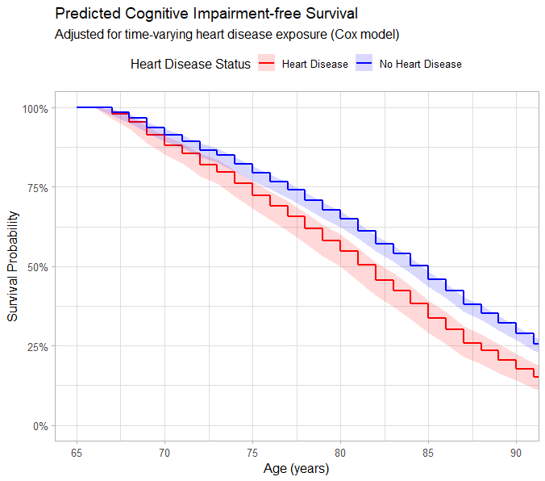 | 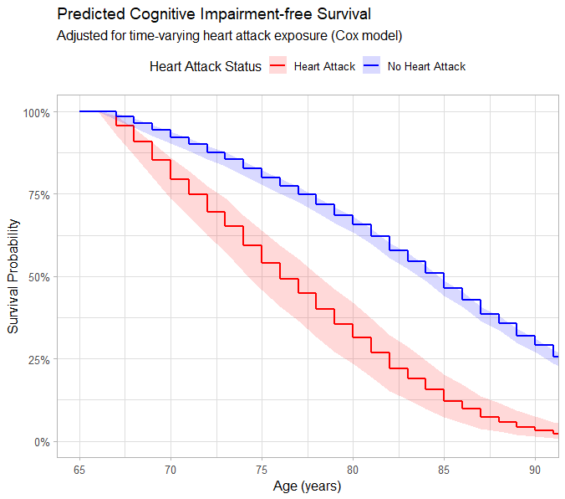
Figure 2: Predicted cognitive impairment-free survival probabilities from a time-varying Cox proportional hazards model. Curves are conditional on cognitive impairment-free survival to age 65 (study entry). Shaded bands represent 95% confidence intervals (used from unadjusted model 1).

Discussion
This study demonstrates association of heart disease or heart attack with the risk of cognitive impairment. Our findings indicate that heart disease increases the hazard of cognitive impairment by 34%, heart attack increases the hazard of cognitive impairment by nearly threefold (HR: 2.75) in the fully adjusted model. Interestingly, age-stratified analyses revealed that the impact of general heart disease was most pronounced in participants aged 75 and older, whereas the detrimental effects of a heart attack were consistent and severe across both age groups and sexes.
A meta-analysis of cohort studies had shown that heart disease was associated with the 45% increased risk of dementia, cognitive impairment or cognitive decline, whereas heart attack increased risk by 46%. They align with the findings of our study that there is increased risk of cognitive impairment with heart disease or heart attack [17].

Heart disease and heart attack are associated with cardiac complications such as atrial fibrillation, and heart failure, whose association with cognitive impairment or dementia is well-established[18, 19]. Heart disease leading to vascular insufficiency can cause hypoperfusion of brain [20], white matter lesions and brain infarctions[21], which in turn are associated with reduced cognitive functioning and risk of dementia. Heart disease and heart attack might however not be causally related to cognition, but brain-effects (e.g. cognitive impairment with vascular origin) might be due to underlying atherosclerosis, which increases both the risk of CHD and dementia[17].

Policy makers and health professionals must be aware that identification of individuals at high risk for cardiovascular disease or dementia is essential to intervene at an early stage by targeting shared modifiable risk factors (e.g. obesity, hypercholesterolemia, physical inactivity, hypertension, smoking).

Strengths and Limitations
There are several strengths of this study. First, the sample size is large which provides sufficient statistical power for robust hypothesis testing. Second, this study is incident-incident design in which exposure (heart disease or heart attack) and outcome are both are incident, which minimizes prevalent exposure bias and reverse causation. This design strengthens the evidence for a temporal relationship between heart disease and heart attack with subsequent cognitive impairment. Third, the use of counting process method prevents the immortal time bias which might otherwise occur by misclassifying individual before exposure occurred. Fourth, we applied weighted analysis to account complex survey design and non-response rate, ensuring the findings are representative. Furthermore, subgroup analysis by age and sex provides a more nuanced clinical picture.
There are some limitations. First, we have not considered the participants developing heart disease and heart attack and cognitive impairment in same wave were not excluded that may dilute the temporality of relationship between cardiac events and cognitive impairment. Second, heart disease and heart attack are self-reported by participants which had a risk of recall bias and measurement error. Third, cognitive impairment was based on screening tools rather than a full clinical diagnosis which also may lead to misclassification. Fourth, participants with severe heart disease or heart attack may have died before developing the cognitive impairment which may have led to underestimation of the true hazard. Furthermore, even with adjustments with the available covariates, there may be unmeasured confounders such as genetic factors and medications or severity of heart disease leading to the biased estimates.

Conclusion
This study highlighted that presence of heart disease or heart attack increases the risk of cognitive impairment. Heart attack is associated with a nearly threefold increase in hazard and 8 years earlier onset of cognitive impairment. The findings suggested the importance of cardiovascular management to reduce or delay cognitive impairment in aging populations. Public health initiatives should focus on integrated care models that target shared modifiable risk factors to reduce the escalating burden of both cardiovascular and cognitive diseases.

References
1. Dhakal A, Bobrin BD. Cognitive Deficits. In: StatPearls. Treasure Island (FL): StatPearls Publishing; 2026.
2. Gracner T, Chaturvedi R, Nguyen P, Heun‐Johnson H, Tysinger B, Goldman D, et al. The burden of cognitive impairment. Alzheimers Dement. 2025;21:e70436. https://doi.org/10.1002/alz.70436.
3. Dementia. https://www.who.int/news-room/fact-sheets/detail/dementia. Accessed 4 Apr 2026.
4. Bai W, Chen P, Cai H, Zhang Q, Su Z, Cheung T, et al. Worldwide prevalence of mild cognitive impairment among community dwellers aged 50 years and older: a meta-analysis and systematic review of epidemiology studies. Age Ageing. 2022;51:afac173. https://doi.org/10.1093/ageing/afac173.
5. Zhang Y, Natale G, Clouston S. Incidence of Mild Cognitive Impairment, Conversion to Probable Dementia, and Mortality. Am J Alzheimers Dis Other Demen. 2021;36:15333175211012235. https://doi.org/10.1177/15333175211012235.
6. Global Burden of Cardiovascular Diseases and Risks 2023 Collaborators. Global, Regional, and National Burden of Cardiovascular Diseases and Risk Factors in 204 Countries and Territories, 1990-2023. JACC. 2025;86:2167–243. https://doi.org/10.1016/j.jacc.2025.08.015.
7. Heart Disease and Stroke Statistics—2023 Update: A Report From the American Heart Association - PMC. https://pmc.ncbi.nlm.nih.gov/articles/PMC12135016/. Accessed 5 Apr 2026.
8. van Nieuwkerk AC, Delewi R, Wolters FJ, Muller M, Daemen M, Biessels GJ, et al. Cognitive Impairment in Patients With Cardiac Disease: Implications for Clinical Practice. Stroke. 2023;54:2181–91. https://doi.org/10.1161/STROKEAHA.123.040499.
9. Yazdanyar A, Newman AB. The Burden of Cardiovascular Disease in the Elderly: Morbidity, Mortality, and Costs. Clin Geriatr Med. 2009;25:563–vii. https://doi.org/10.1016/j.cger.2009.07.007.
10. Tsao CW, Aday AW, Almarzooq ZI, Alonso A, Beaton AZ, Bittencourt MS, et al. Heart Disease and Stroke Statistics—2022 Update: A Report From the American Heart Association. Circulation. 2022;145:e153–639. https://doi.org/10.1161/CIR.0000000000001052.
11. Neurocognition and Cerebral Lesion Burden in High-Risk Patients Before Undergoing Transcatheter Aortic Valve Replacement: Insights From the SENTINEL Trial | JACC: Cardiovascular Interventions. https://www.jacc.org/doi/abs/10.1016/j.jcin.2017.10.041. Accessed 5 Apr 2026.
12. van Nieuwkerk AC, Delewi R, Wolters FJ, Muller M, Daemen M, Biessels GJ, et al. Cognitive Impairment in Patients With Cardiac Disease: Implications for Clinical Practice. Stroke. 2023;54:2181–91. https://doi.org/10.1161/STROKEAHA.123.040499.
13. National Health and Aging Trends Study. Produced and distributed by www.nhats.org with funding from the National Institute on Aging and Office of Behavioral and Social Sciences Research (OBSSR) (grant number U01AG032947).
14. About NHATS & NSOC | NHATS. https://www.nhats.org/about. Accessed 20 Mar 2026.
15. Albert MS, DeKosky ST, Dickson D, Dubois B, Feldman HH, Fox NC, et al. The diagnosis of mild cognitive impairment due to Alzheimer’s disease: Recommendations from the National Institute on Aging-Alzheimer’s Association workgroups on diagnostic guidelines for Alzheimer’s disease. Alzheimers Dement. 2011;7:270–9. https://doi.org/10.1016/j.jalz.2011.03.008.
16. Federal Poverty Level (FPL) - Glossary. HealthCare.gov. https://www.healthcare.gov/glossary/federal-poverty-level-fpl. Accessed 4 Apr 2026.
17. Deckers K, Schievink SHJ, Rodriquez MMF, Oostenbrugge RJ van, Boxtel MPJ van, Verhey FRJ, et al. Coronary heart disease and risk for cognitive impairment or dementia: Systematic review and meta-analysis. PLOS ONE. 2017;12:e0184244. https://doi.org/10.1371/journal.pone.0184244.
18. Justin BN, Turek M, Hakim AM. Heart disease as a risk factor for dementia. Clin Epidemiol. 2013;5:135–45. https://doi.org/10.2147/CLEP.S30621.
19. Kalantarian S, Stern TA, Mansour M, Ruskin JN. Cognitive Impairment Associated With Atrial Fibrillation. Ann Intern Med. 2013;158 5_Part_1:338–46. https://doi.org/10.7326/0003-4819-158-5-201303050-00007.
20. Gruhn N, Larsen FS, Boesgaard S, Knudsen GM, Mortensen SA, Thomsen G, et al. Cerebral Blood Flow in Patients With Chronic Heart Failure Before and After Heart Transplantation. Stroke. 2001;32:2530–3. https://doi.org/10.1161/hs1101.098360.
21. Ikram MA, Vernooij MW, Hofman A, Niessen WJ, van der Lugt A, Breteler MMB. Kidney Function Is Related to Cerebral Small Vessel Disease. Stroke. 2008;39:55–61. https://doi.org/10.1161/STROKEAHA.107.493494.

